Oprea Sergiu-Daniel, Gr. 30322, Homework Lab 10

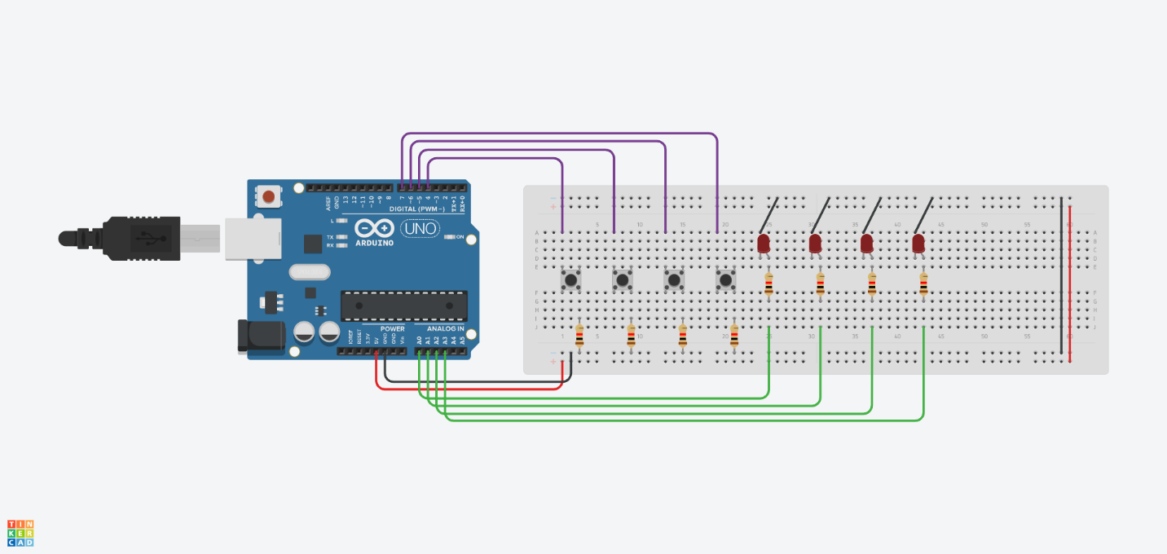Ex1 a.

volatile bool prevButtonState[4] = { 0, 0, 0, 0 };

volatile bool ledIsOn[4] = { 0, 0, 0, 0 };

void setup() {

// Buttons

pinMode( INPUT_PULLUP) ;

pinMode( INPUT_PULLUP) ;

pinMode( INPUT_PULLUP) ;

pinMode( INPUT_PULLUP) ;

// LEDs

pinMode(A0, OUTPUT); digitalWrite(A0, LOW);

pinMode(A1, OUTPUT); digitalWrite(A1, LOW);

pinMode(A2, OUTPUT); digitalWrite(A2, LOW);

pinMode(A3, OUTPUT); digitalWrite(A3, LOW);

Serial.begin(9600);

}

void loop() {

for (byte i = 0; i < 4; i++) {

bool state = digitalRead(i + 4);

if (state ≠ prevButtonState[i]) {

prevButtonState[i] = state;

if (state == LOW) {

if (!ledIsOn[i]) {

digitatWrite(A0 + i, HIGH);

ledIsOn[i] = true;

} else {

digitalWrite(A0 + i, LOW);

ledIsOn[i] = false;

}

}

}

}

delay(20);

}

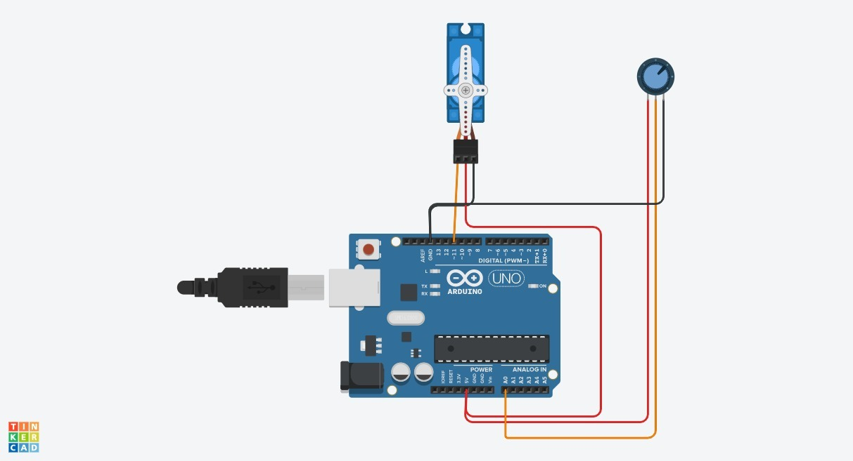b.

#include <Servo.h> // add servo library

Servo myservo; // create servo object to control a servo

int potpin = 0; // analog pin used to connect the potentiometer

int val; // variable to read the value from the analog pin

void setup() {

myservo.attach(9); // attaches the servo on pin 9 to the servo object

}

void loop() {

// reads the value of the potentiometer (value between 0 and 1023)

val = map(val, 0, 1023, 0, 180); // scale it to use it with the servo (value between 0 and 180)

myservo.write(val); // sets the servo position according to the scaled value

delay(15); // waits for the servo to get there

}

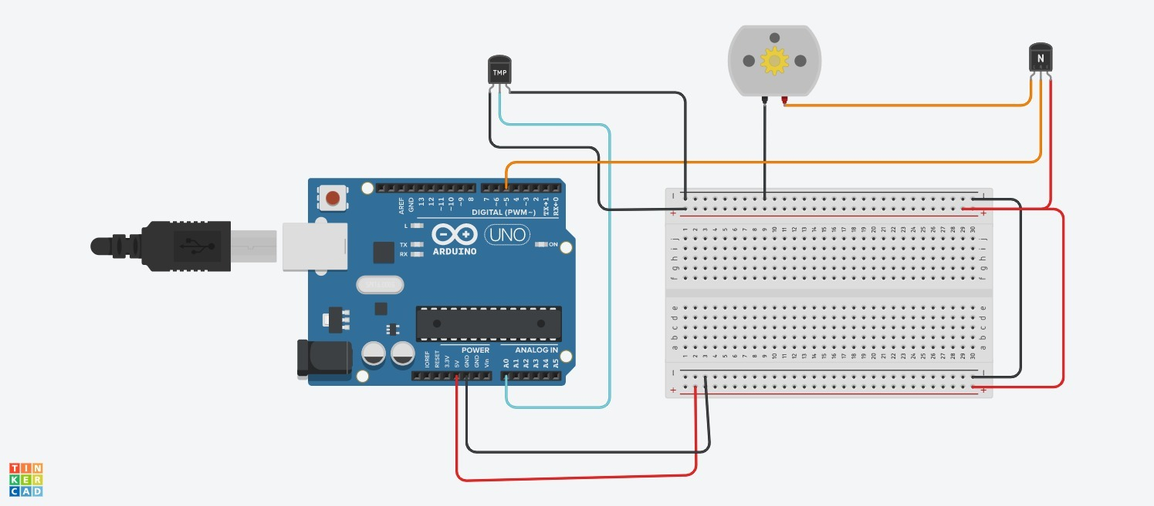

// C++ code

//

#define TEMP A1

void setup(){

pinMode(3,OUTPUT);

Serial.begin(9600);

}

void loop()

{

int read = analogRead(TEMP);

delay(1000);

float volt=read*5;

volt/=1023;

float temp=(volt-0.5)*100;

Serial.println(temp);

if(temp<=25){

analogWrite(3,50);

}

else if(temp>25 && temp < 35)

analogWrite(3,100);

else if(temp >=35 )

analogWrite(3,255);

}

c.

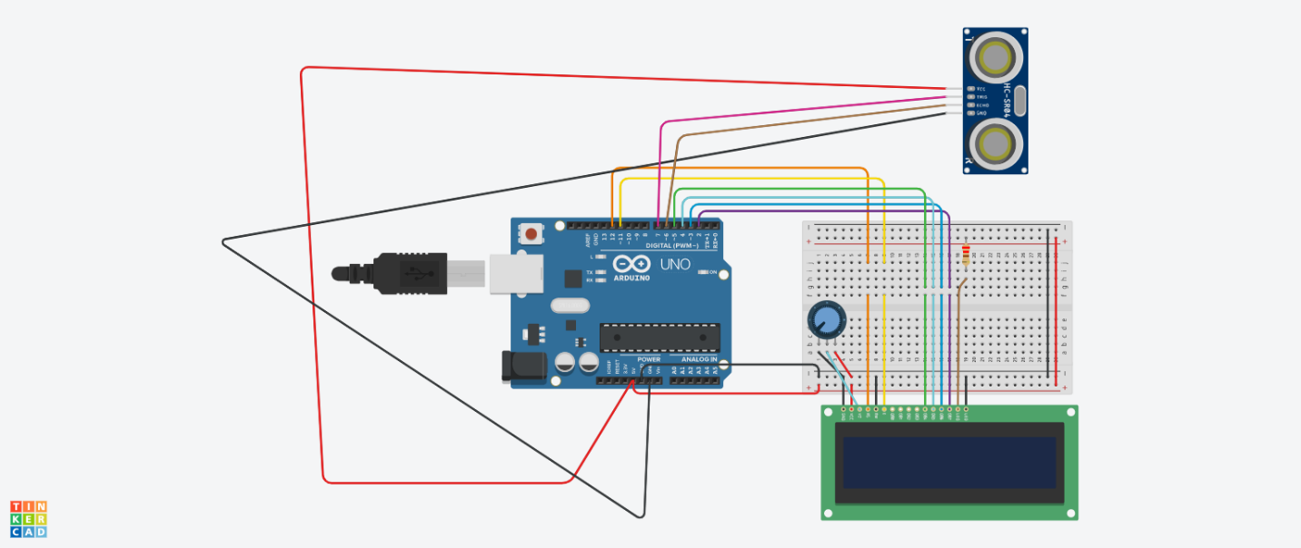

#include <LiquidCrystal.h>

LiquidCrystal lcd(12 , 11, 5, 4, 3, 2);

const int trigPin = 7;

const int echoPin = 6;

long duration;

int distanceCm, distanceInch;

void setup()

Serial.begin(9600);

lcd.begin(16,2);

pinMode(trigPin, OUTPUT);

pinMode(echoPin, INPUT);

}

void loop() {

digitalWrite(trigPin, LOW);

delayMicroseconds(2);

digitalWrite(trigPin, HIGH);

delayMicroseconds(10);

digitalWrite(trigPin, LOW);

duration = pulseIn(echoPin, HIGH);

distanceCm= duration*0.034/2;

distanceInch = duration*0.0133/2;

Serial.println(distanceCm);

lcd.setCursor(0,0);

lcd.print("Distance: ");

lcd.print(distanceCm);

lcd.print("cm");

delay(10);

lcd.setCursor(0,1);

lcd.print("Distance: ");

lcd.print(distanceInch);

lcd.print("inch");

delay(10);

}